**Lab 1: Building Tables & Inserting Records**

1. Build the Cars table and insert records as directed in the lesson(s).  
     
   A screenshot of a computer

   Description automatically generated  
     
   A screenshot of a computer

   Description automatically generated
2. Build the Products table based on the following table design:  
     
   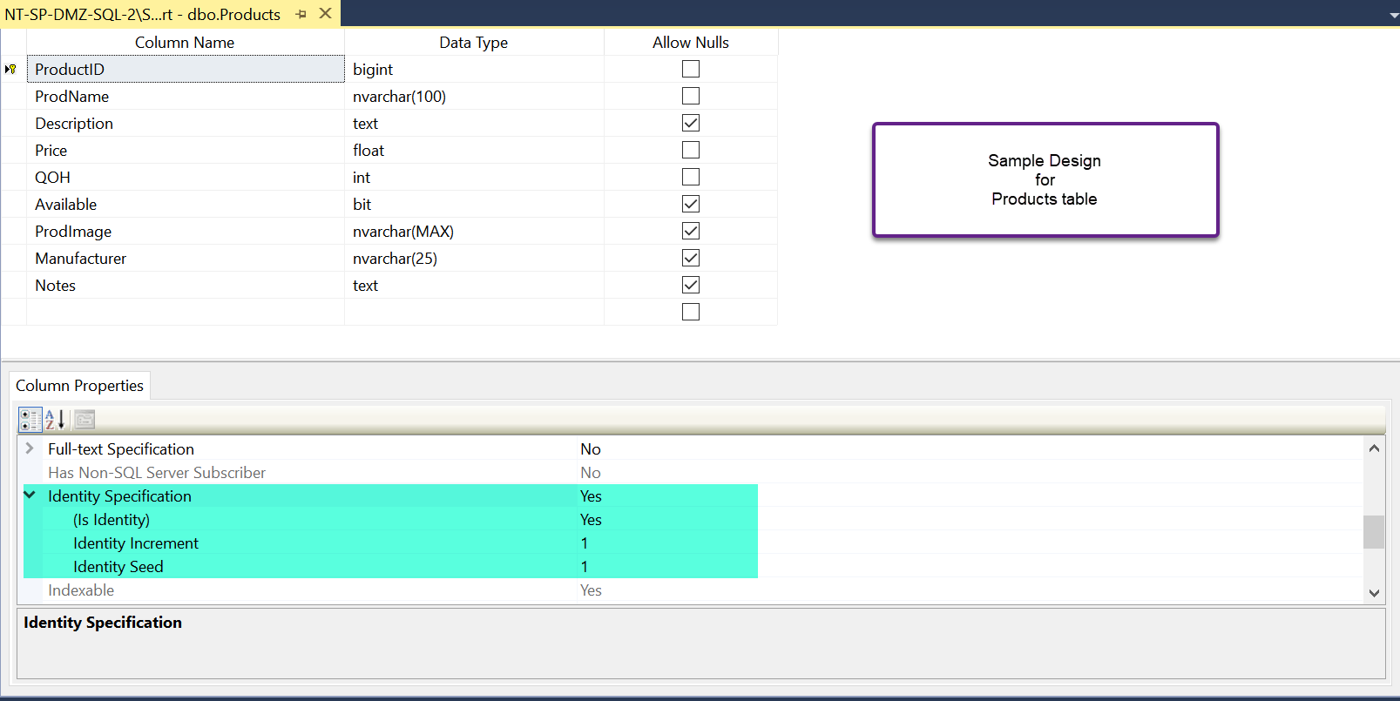
3. Populate the records to match those below:  
     
   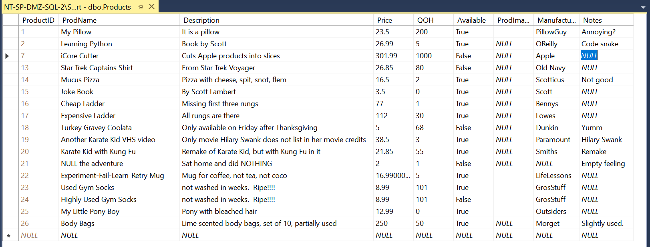  
     
   PLEASE NOTE: Your ProductID’s will not match mine…that is okay. I deleted a series of other records along the way.
4. Create 6 more records of your own.  Please try to create a variety of records with diverse field values for testing.